



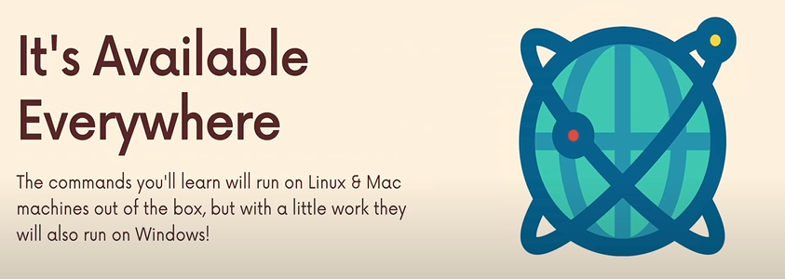



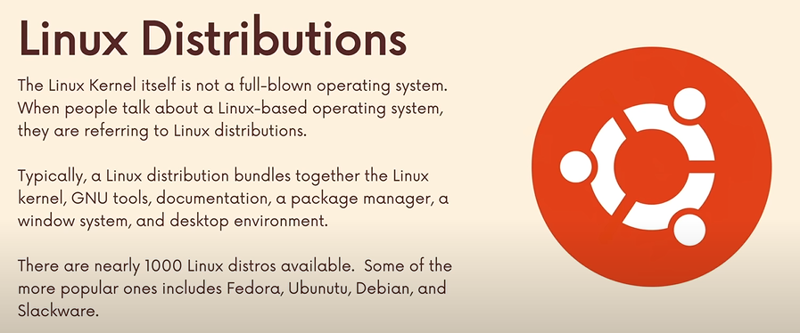

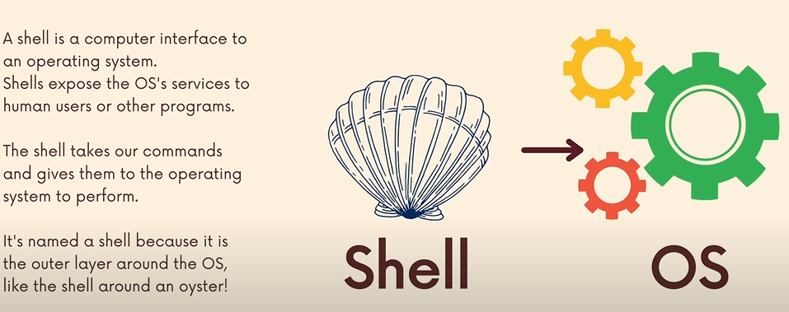

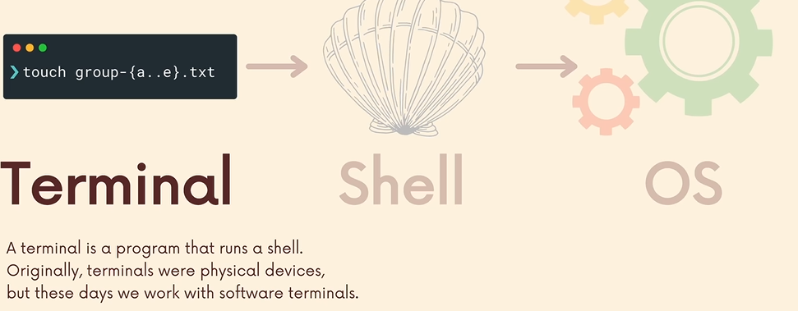

The job of the shell (BASH) is to take the commands provided by the user/applications and give it to the operating system so that it can make some sense out of it.

Terminal is a piece of software that can connect with different shells.

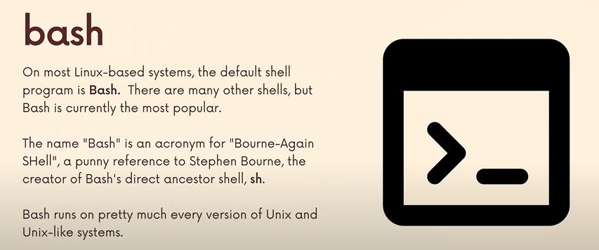

To scroll down one page at a time in the shell, use ‘space’.

All absolute paths start with ‘**/**’ because the highest level directory is the slash/root directory.

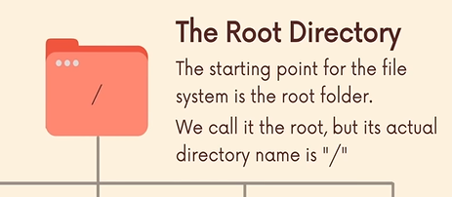

**1)**

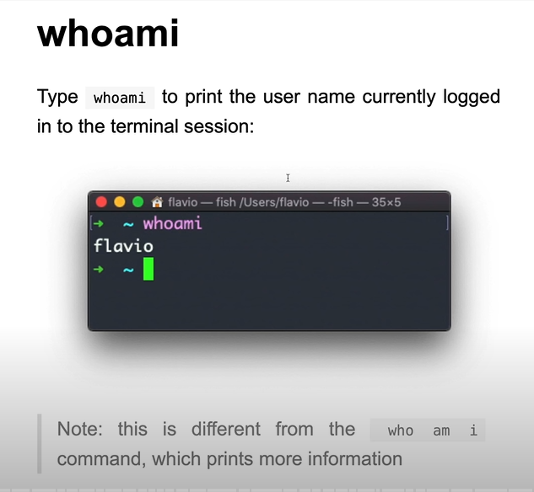

**2)**

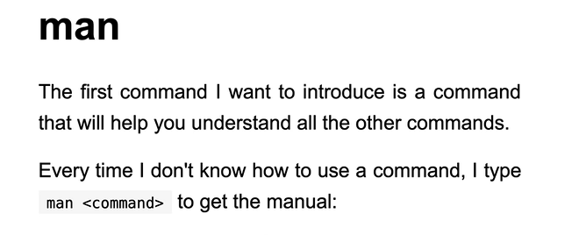

**3)**

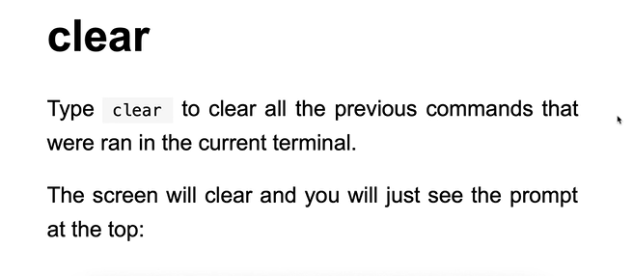

Synopsis is showing us the accepted options/values that we can pass to the clear command.

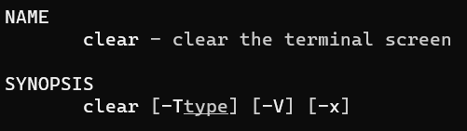

Commands accept options that alter their behaviour. We can change how a command functions.

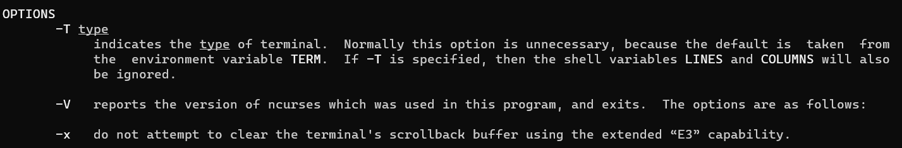

For example passing the **x** option to the clear command will not clear the scroll-back history.

**clear -x**

Another shortcut instead of typing clear is to use **ctrl L**.

**4)**

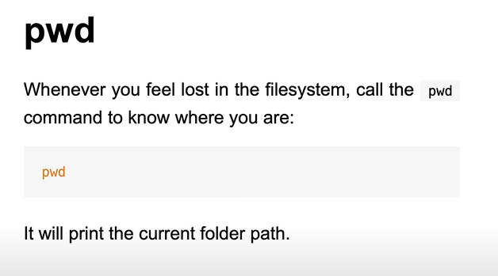

Tells our current location in a given terminal window. (current working directory)

**5)** We can either provide a relative path from our current location or any absolute location of a file present anywhere on our machine.

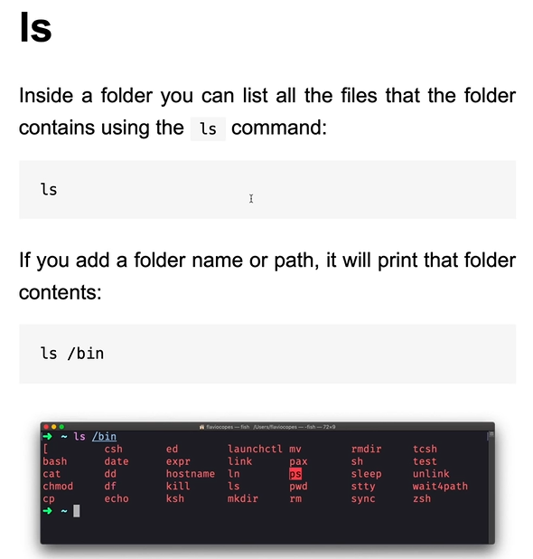

If we type **ls – a** then we will get all files/folders starting with **.** aswell.

**ls – l** will provide us with the long format.

We can use multiple options together aswell: **ls – a -l** or **ls -al**

**6)**

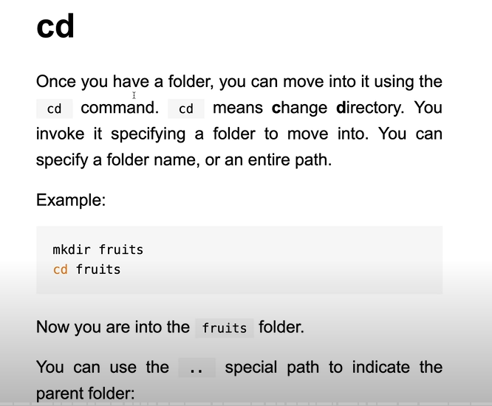

**man cd** wont work because cd doesn’t have a manual page since it is implemented by the shell. Hence, we run **help cd**.

To go back multiple times we can use **cd../../..**

**cd ~** takes us to the home directory.

**7)**

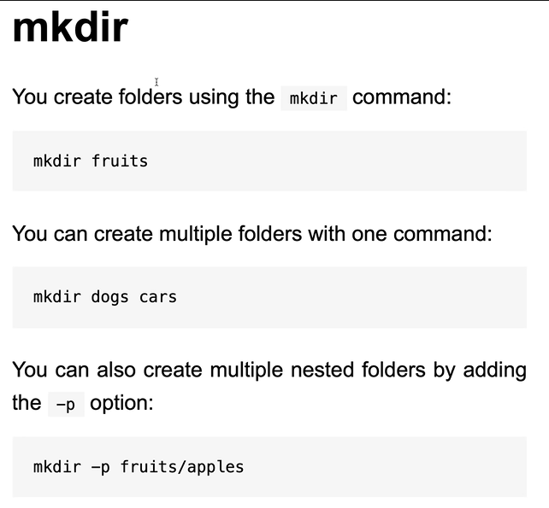

The p option is very useful as it creates the parent directory automatically (in case it didn’t exist already).

**8)**

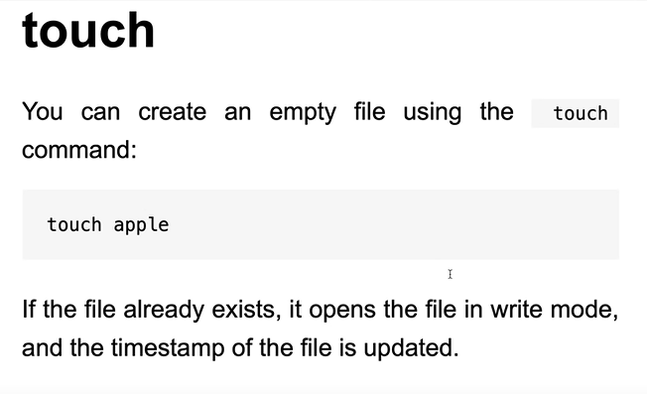

This command is called touch and not something like “make-file” or anything because historically, its purpose was to change the access and modification time of a file (if we for example write touch apple and apple file exists already, then its timestamp is updated. However, if the file was not present already, then a new empty version of it is created).

We can view these access modification times using **ls -l**.

**9)** Only works to remove an empty directory.

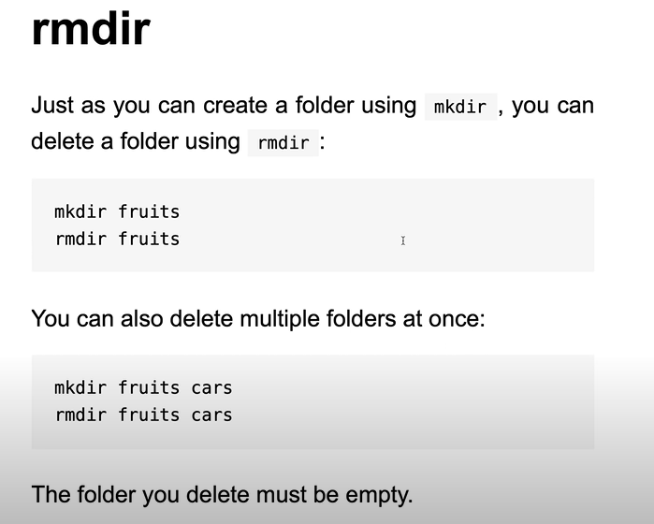

**10) rm** Used to delete files/directories.

To delete files we simply do **rm filename**

The **v** flag/option when used with rm (stands for verbose) gives us the information of what the command did.

Eg **rm -v apple banana**.



To delete a directory, we have to use a flag along with the rm command.

**r** flag for recursive. (This flag tells the rm command to remove a directory and all of its contents)

Eg **rm -r foldername**

**11)** (MAC specific command) To use it on ubuntu, type **xdg-open filename**

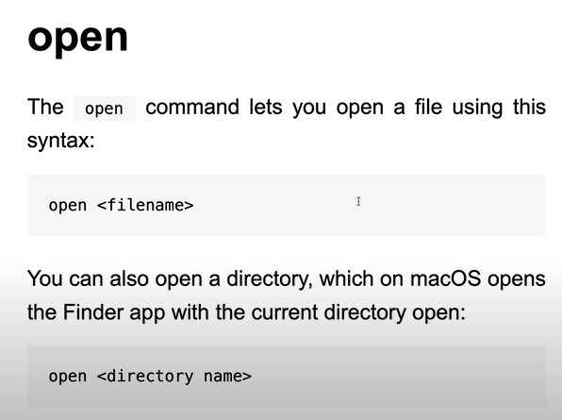

**12)** To use this command to rename files type **mv oldName newname.**

To use this command to move files between directories type **mv file1 file2 folder**

**The move command is smart enough to notice that if the last argument/parameter is a folder, then it is the destination folder.**

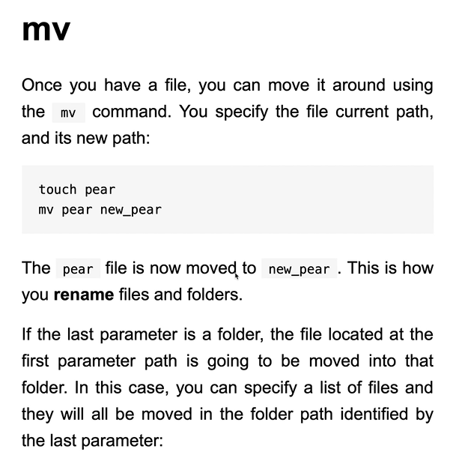

**13)** If we want to make the copy within the same folder then we just type **cd old new**

If we want to make a copy within another directory, then we type **cd oldfile folder/new**

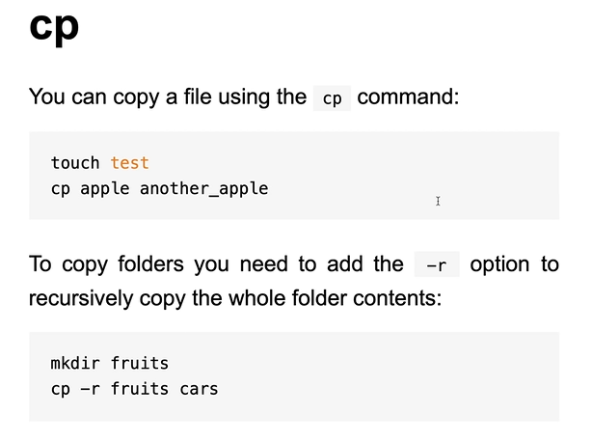

**14) head filename**

**head filename -n 100** will print the first 100 lines of the file

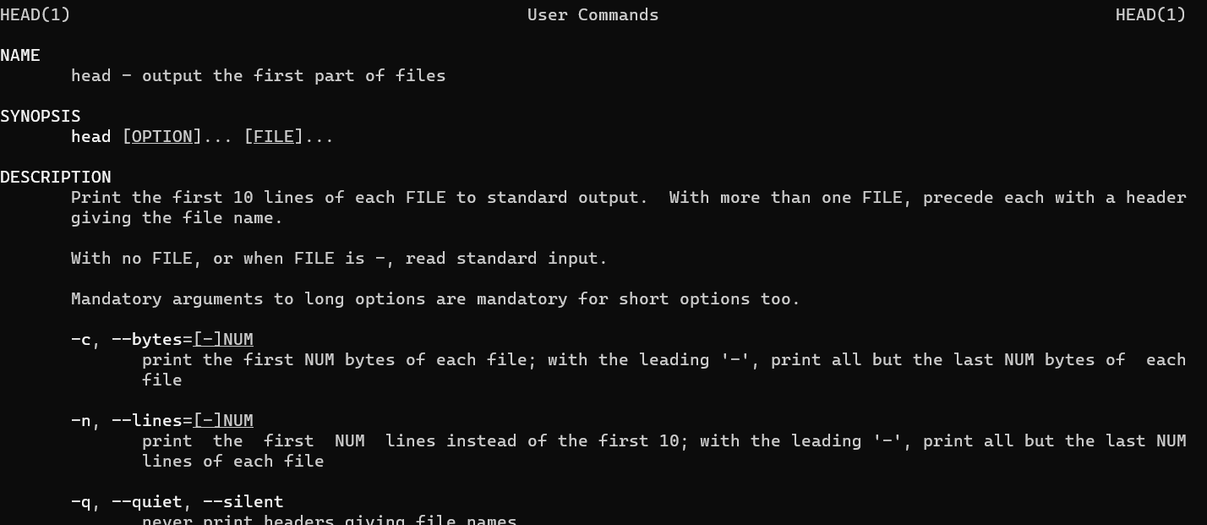

**15) tail filename**

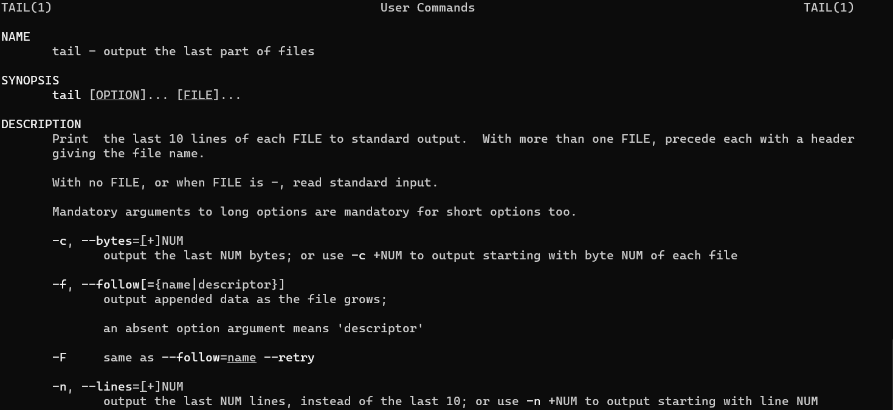

**16) date**

**17) Redirecting Standard Output:** instead of showing up the output as text on the terminal, we can redirect this information (eg store it in a file).

To do use we use this syntax:

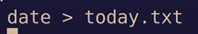

This tells the terminal to run the date command first and whatever output we get, don’t just print it out. Instead, redirect this output to the today.txt file. If we now type **head today.txt** we can view its contents.

**\*\*\*This command will not add content to a file which already contains some content, rather, it will replace it!\*\*\***

**Hence,** we can use **>>** which allows us to redirect the content to a file while appending it and not overwriting it.

Also, the file need not exist prior to redirecting content to it, we can simply redirect the content and if the file isn’t present, then it will automatically be created for us.

**18)** The name cat comes from the fact that it concatenates the file.

Cat gives us the entire file contents.

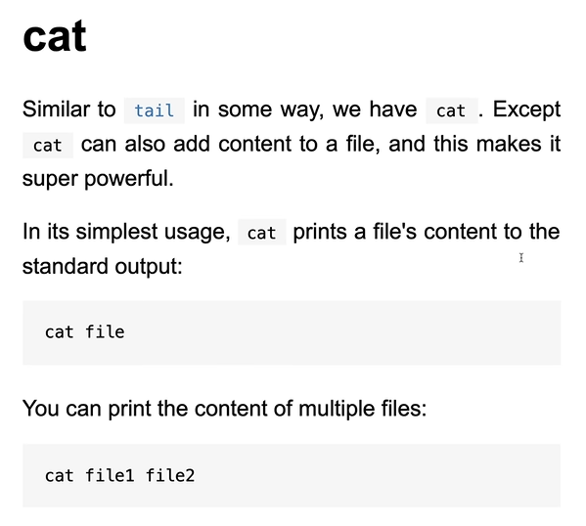

We can redirect the output of multiple files together (basically concatenate) to a single file.

Eg **cat list1 list2 list3 > completelist**

This is useful as we can take/concatenate multiple things and send them to a single file.

**cat -n** provides line numbers aswell.

**19) Less** used to read the contents of a file. Compared to looking at the contents of a file using cat, less provides us with a way better UI.

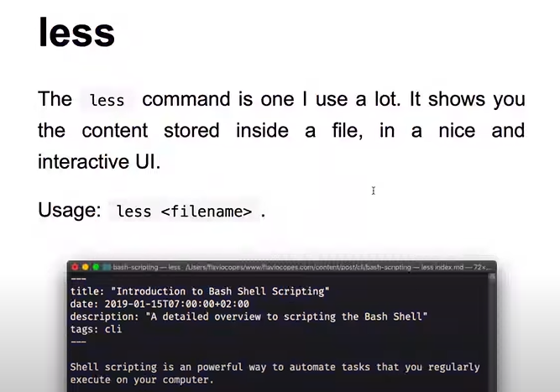

When we run **less file**, the screen opens the program and not just print its entire contents on the screen. We can use space to switch 1 page at a time, use **/green** to search for a particular word in the file.

**Space** to go 1 page down.

**b** to go 1 page up.

**G** last page.

**g** first page.

**20)** Outputs the argument passed to it.

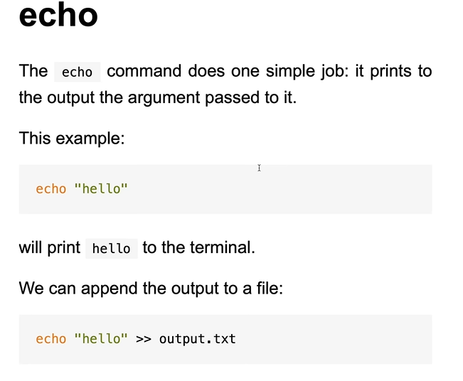

I can echo and redirect text/argument to a file which does not even exist (hence creating a new file with some limited text).



Takes the argument and instead of echoing it, redirects it to a new file (doesn’t exist, makes one on its own).

**21)** Counts the words in some input. Also counts the bytes and the lines.

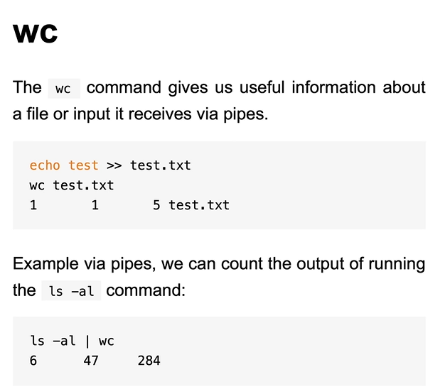



Lines words bytes nameOfFile.

Right now we are directly passing a file to the **wc** command. However, with **piping**, we can take the output of one command and pass it as the input to some other command.

We saw how to take output of command ls and redirect it to a file **ls > file**, however, with piping we are taking the output of a command and passing it to a second command.

**ls -l | wc** this will pass the output of command as the input to command wc.

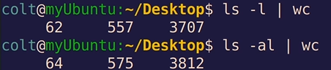

**date | wc** will display lines, words and bytes.

**cat file1.txt file2.txt | wc -l** will print the total lines in the concatenated file 1 and file 2.

**cat file1.txt file2.txt | wc -l > file3.txt** first we are concatenating the two files, then piping it to the wc command which gives us the number of lines and instead of printing it out, we re-direct it a file3.

**22)** It sorts and display the file but does not change its content.

**sort filename**

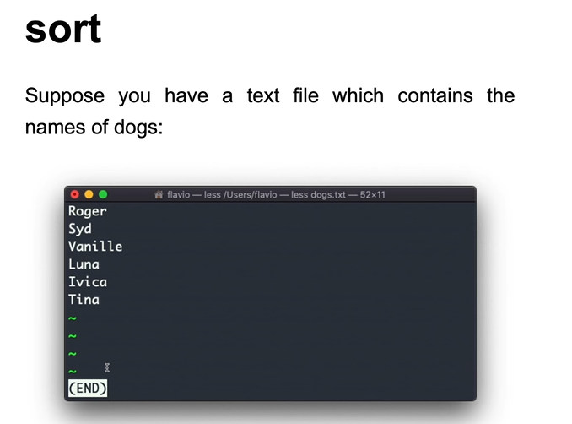

**sort filename > file2** // redirecting sorted content to file2

**sort -n filename** is used to sort numbers

**sort -r filename** is used to reverse the sorted order

We can concatenate files and pipe it to sort **cat f1 f2 | sort**

**sort -nu nums | wc -l** will print the number of unique lines/items.

**23)** This command removes adjacent similar values. That’s the reason of using it along with sort so that all duplicates are removed.

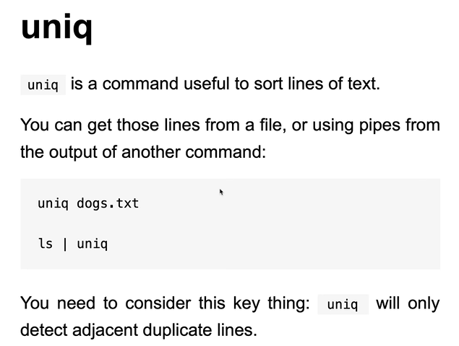

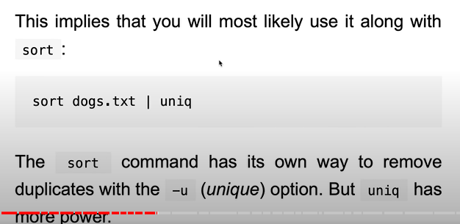

**sort filename | uniq** gives all values but only once.

**sort filename | uniq – d** only gives the duplicated values.

**sort filename | uniq – u** only gives the unique values.

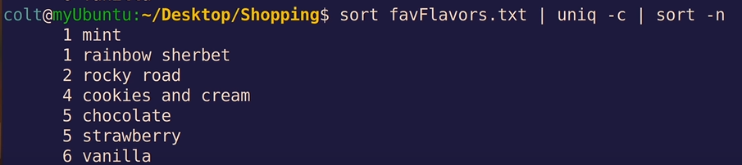

This will first sort alphabetically, then pipe it to the uniq command which is giving us the count of each flavour and further piped to the sort command which sorts it based on its count.

**24) Expansions:** we can use special characters/syntax with various commands that the shell will interpret and expand into some other value.

Eg **~** which is a shortcut to home dir.s

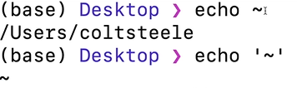

The shell is expanding the tildy character (has a special meaning) before it runs the echo command and then that is what it echos out.

**echo *.txt** matches all files with .txt path. (**\*** matches all paths)

**echo *.???** matches all files with anything.threechars

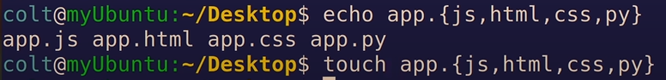

The curly braces will expand whatever we write in there.

We can also provide ranges using **..**

**echo {1..99}**

**The concept of expansion is that the shell intervenes before the command runs and expands the smaller thing into a larger piece of information and passes it to the command. We can use this to create, delete files or match data etc.**

**25)**

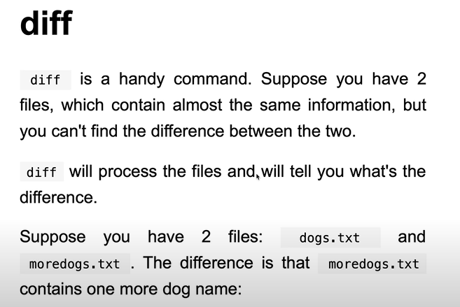

**diff -y file1 file2** is more useful as the y option opens up both the files.

**-u** option is what git uses.

**26)**

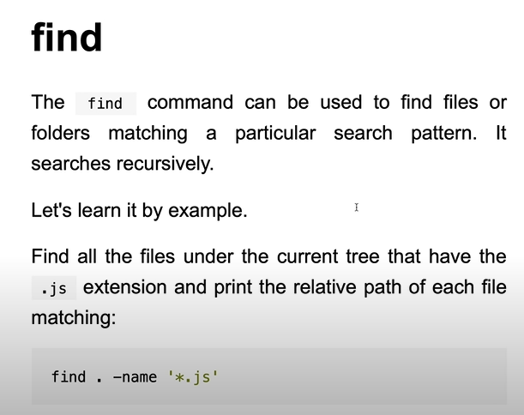

The ‘**\***’ matches anything.

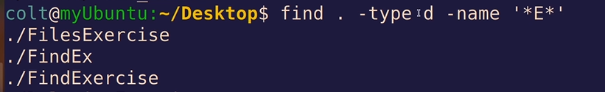

**On the desktop, only directories, having E in their name.**

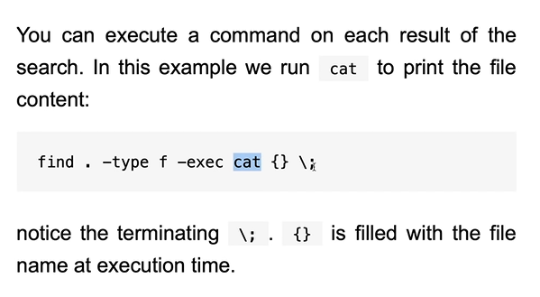

**27) Find** command helps us find file using their names or some other attributes, whereas, grep will search inside the files.

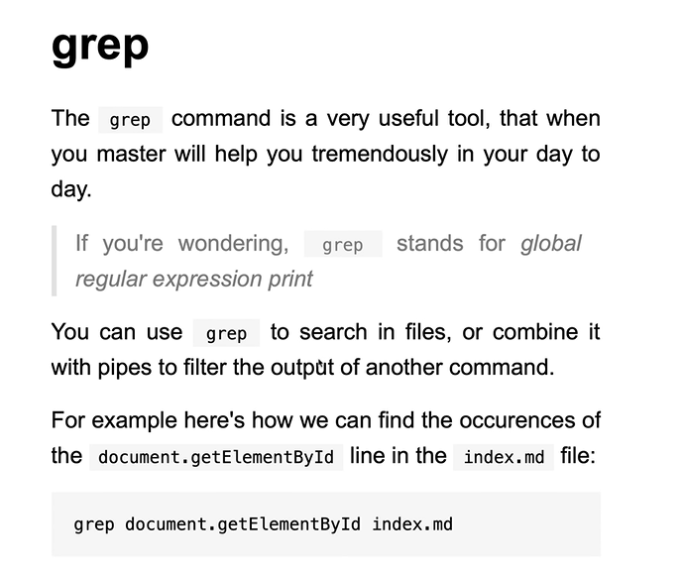

**28) Disk utage: du**

If I run du inside the current directory, then it gives the sizes of all the nested directories.

**du foldername**

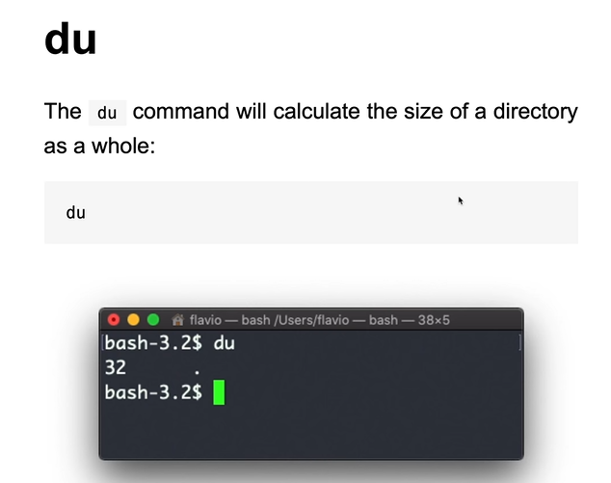

**du – h | sort -h** First we get sizes as per human readable format and then pipe it to sort.

This command shows us the folder/file sizes.

**29)** Tells information about the mounted file system.

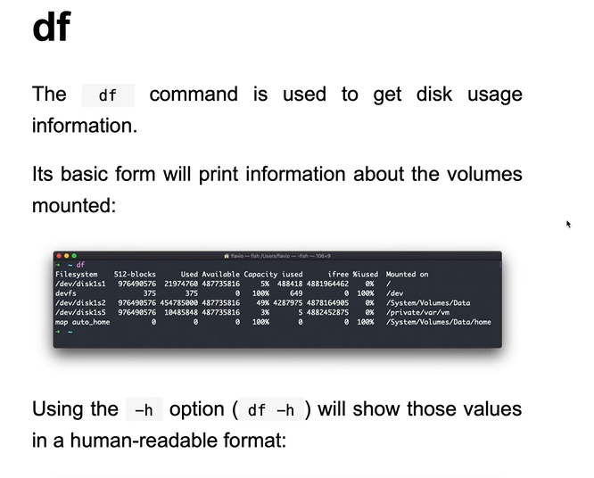

**30)** This is useful if we want to check out a command we wrote many commands back.

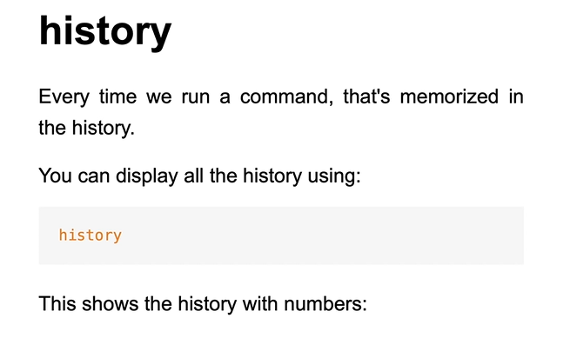

This generates the commands along with their number and we can simply type **!10** to run the 10th command.

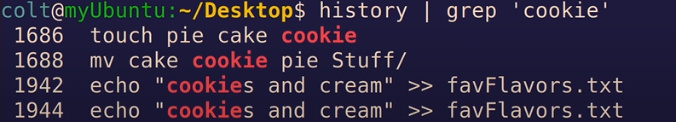

To search for historical commands which included cookie in them, we are passing the output of history command as the input to the grep command.

**31) Process status**

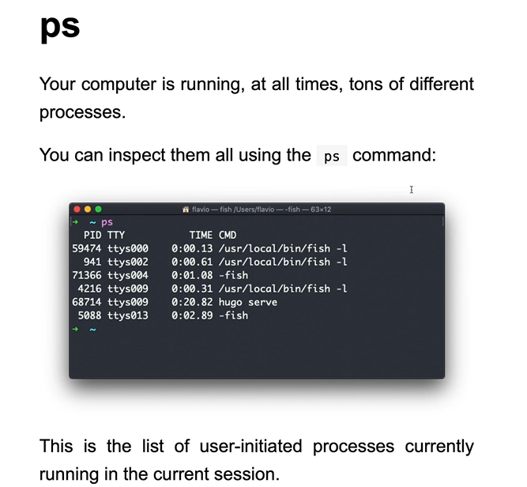

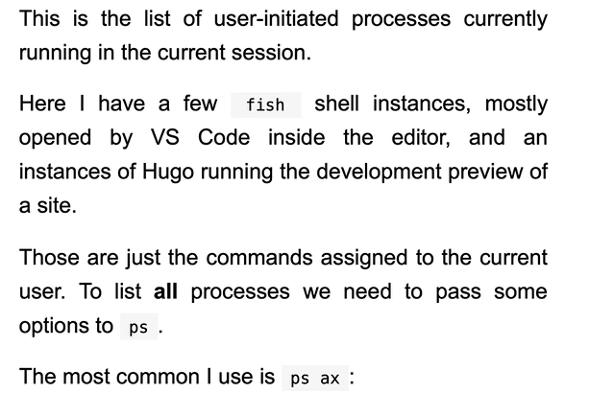

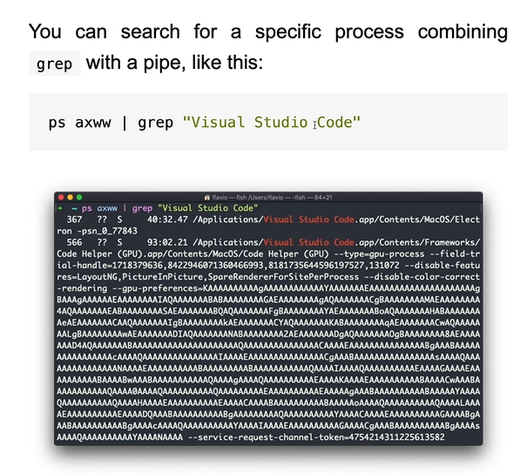

**32)** Shows the topmost cpu intensive processes.

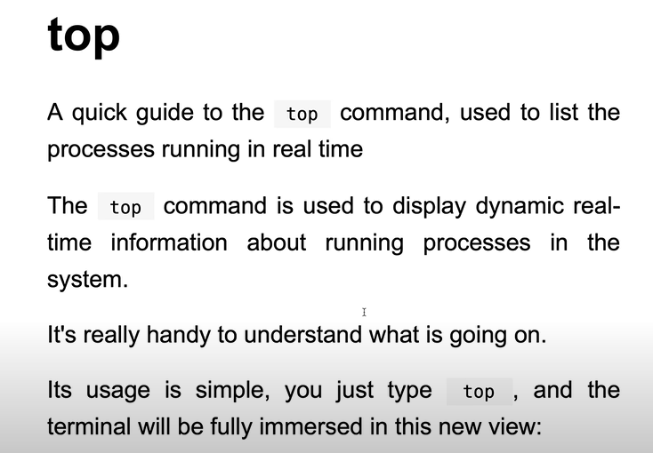

**33)**

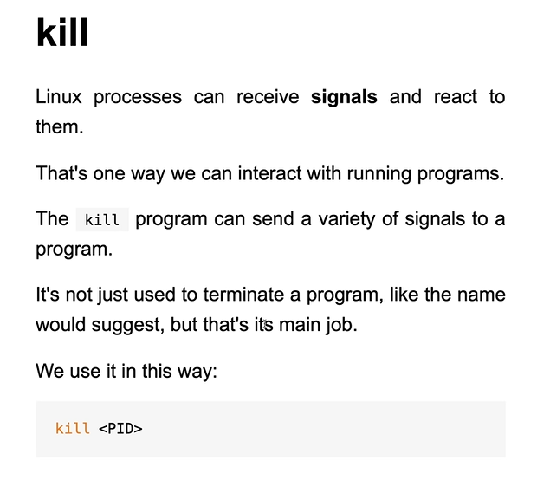

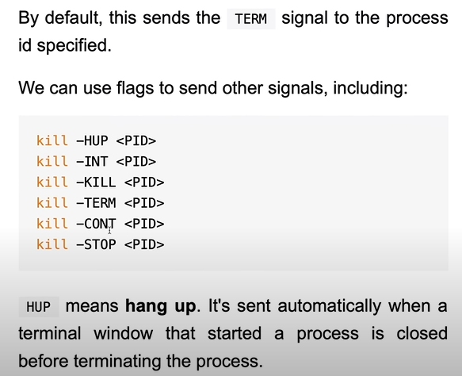

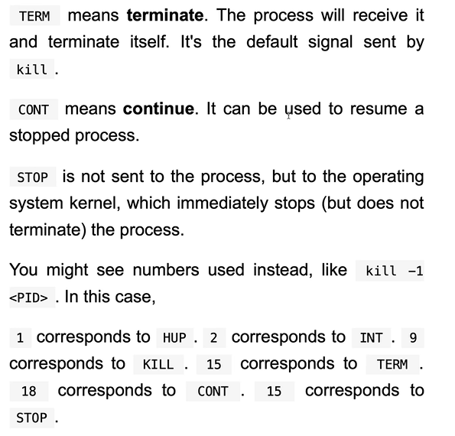

We can send many signals with the kill command.

**Kill -l** will list all the signals we can send to kill.

If we start a node server and have lost the window to close it, then we can kill it.

**34)** Instead of a process ID, we can provide a process name when we use the KILLALL command.

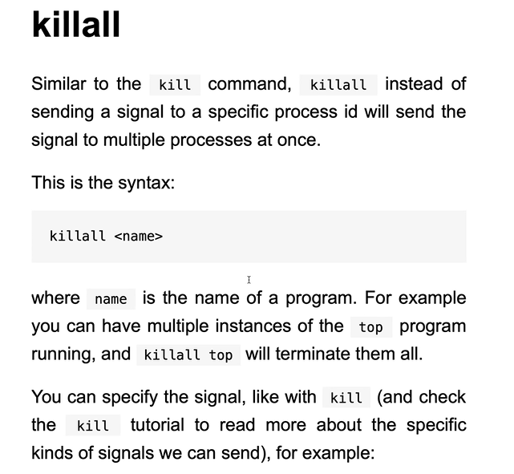

**35)** If we run a very large command and press **ctrl Z**, then the job will be suspended and if we type **jobs** then we will be able to see it in the terminal. Before we suspended the jobs, they were being run in the foreground and we had to interact/view them. However, now we can run them in the background.

If we type **fg 1** then the job 1 will run in the foreground.

If we type **bg 1** then the job 1 will run in the background. We can also use **&** to run a job in the background. **Sleep 50 &** will run this program in the background.

**36)** Even if we type multiple file names in front of the gzip command, it compresses them individually into individual gzip files. Hence, we use **command 38) tar** to achieve this.

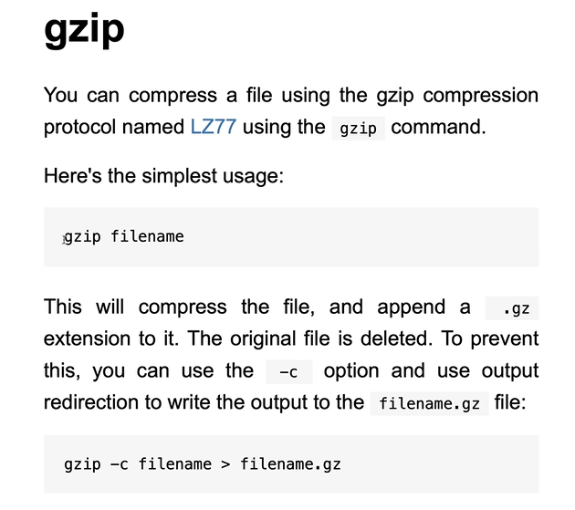

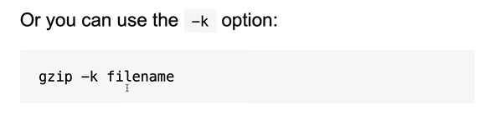

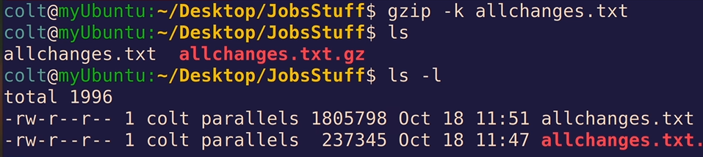

**37)**

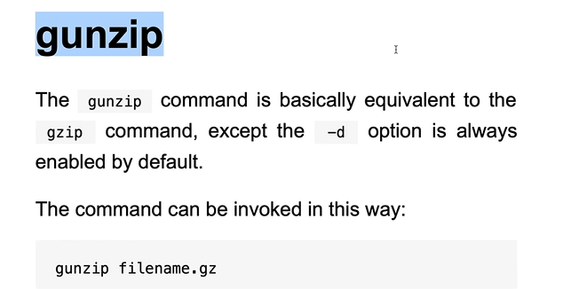

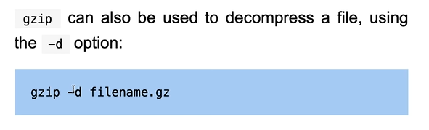

**38)** We can group multiple files together and then compress the obtained file.

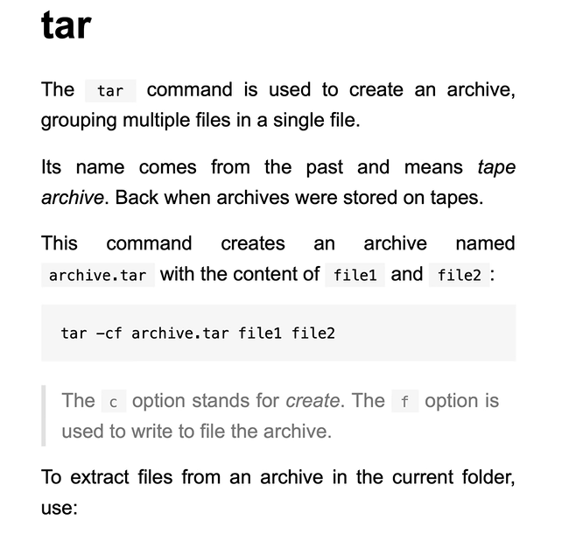

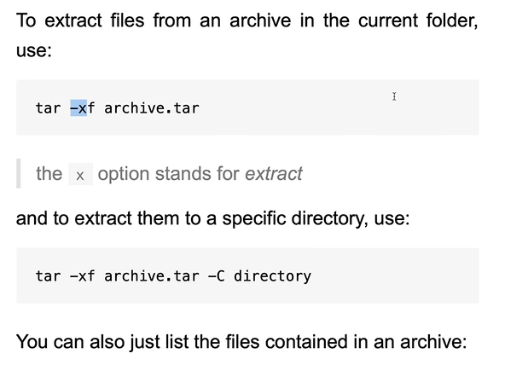

**tar -tf archive.tar**

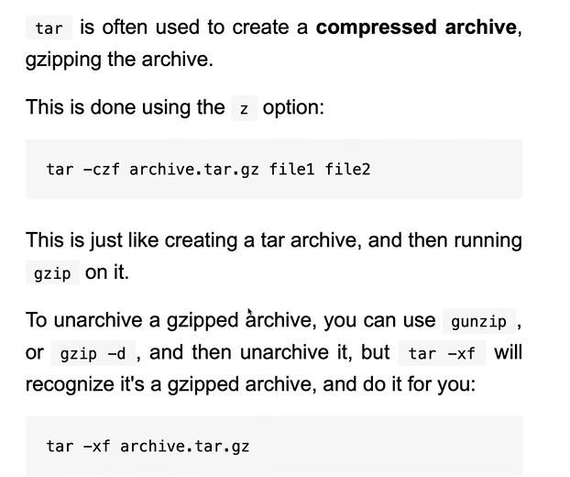

Or I can simply write **gzip archive.tar**

**39)**

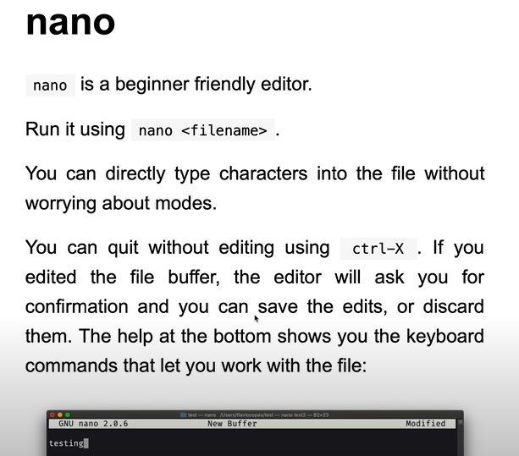

**nano file1.txt** will create a new file and run it.

**40) Alias**

**alias myLS=’ls -la’**

However, we lose the alias when we close the terminal. Hence, if we want to want an alias persist, then we need to put it in a place.

<https://www.youtube.com/watch?v=ZtqBQ68cfJc&t=12900s>

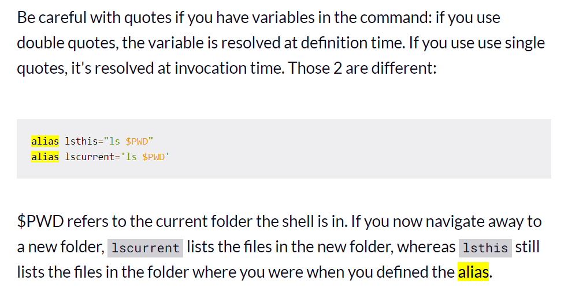

**41)** <https://www.youtube.com/watch?v=ZtqBQ68cfJc&t=13400s>

**42)** Eg: shortcut icon on the desktop for a file which might be located anywhere on our pc.

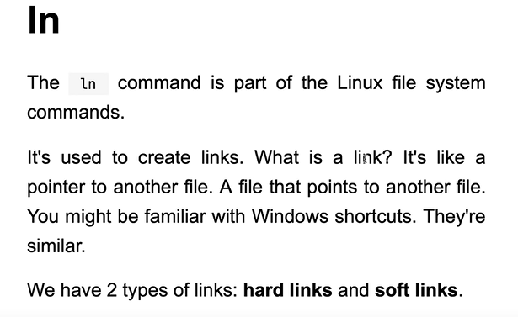

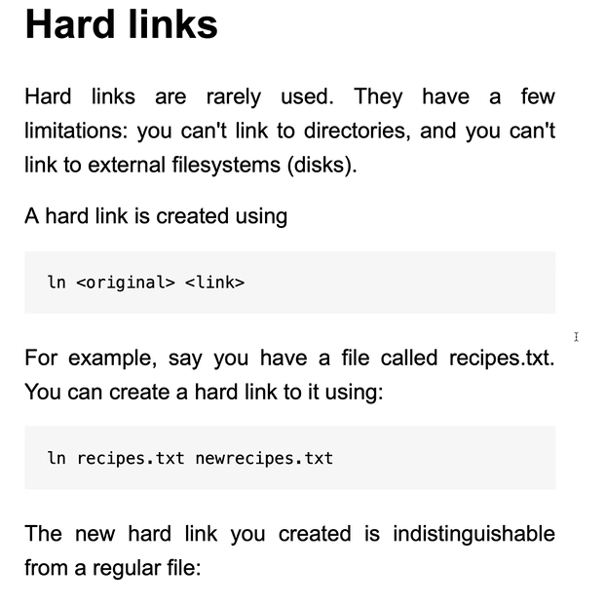

Using hardlink: These 2 file names will point to the same location in memory and deleting one of them wont lead to the deletion of the other one (since the other one is still pointing to that memory). We can change the file contents using either of the links and it will reflect the changes for both since both links are referring to the same place in memory. Deleting one wont delete for the other.

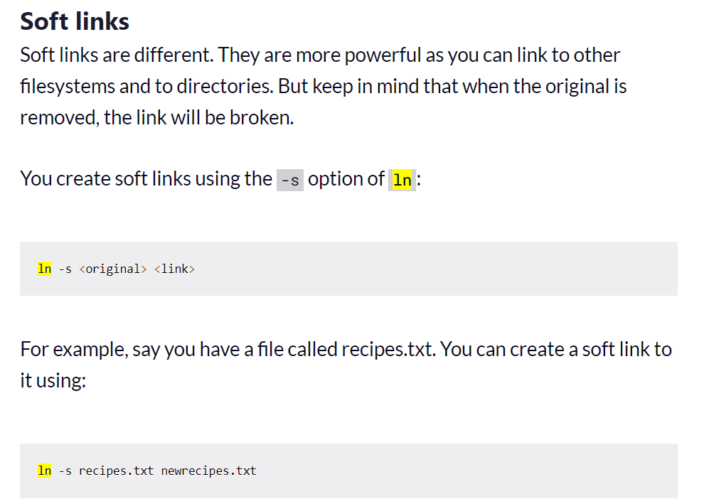

Here also if we type **echo “CHANGE FROM COPY” >> newrecipe** then the changes are reflected for both. If we delete the main copy then the linked copy is deleted.

**In hard links, there were 2 different pointers, pointing to the same thing in memory whereas, in soft link we can say that the newly created pointer was pointing to the original one.**

**43)**

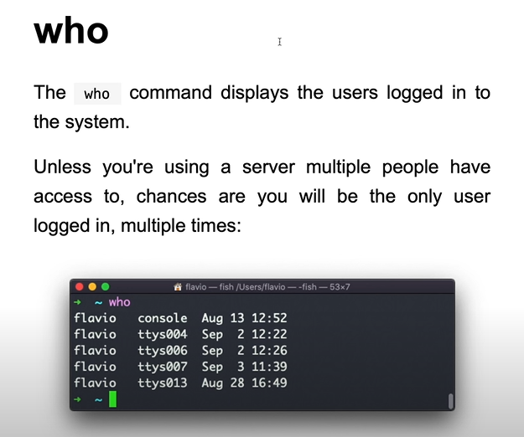

**44) This only switches user in the particular tab/window.**

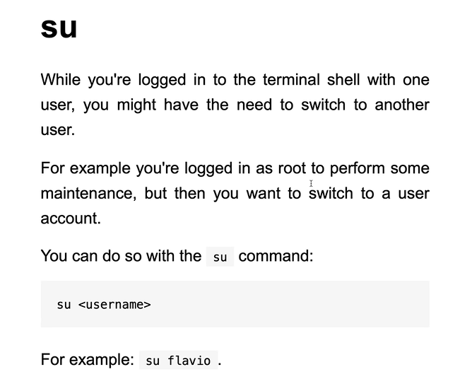

**45)**

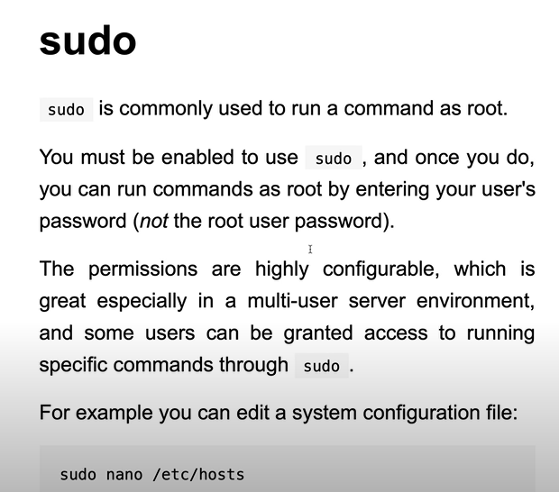

**46) This command is useful because if a user has forgotten his/her password then we can change it from the admin account.**

**sudo password profileforwhosenamehastobechanged** // hence we can change pass

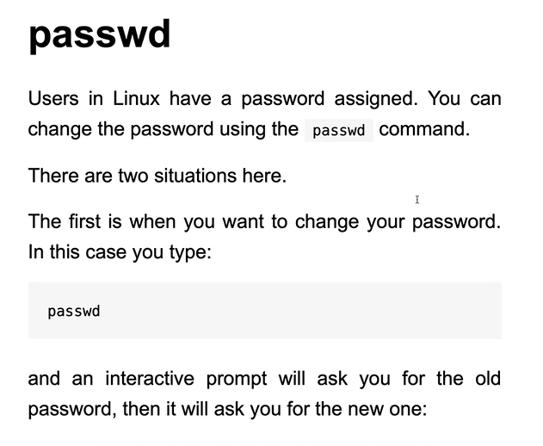

**47) This command is used to change who owns the particular file/directory.**

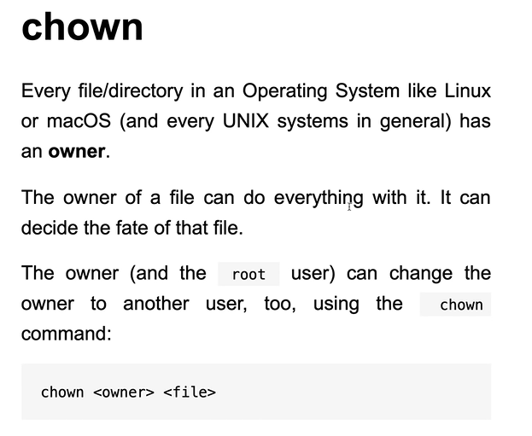

**If we don’t use -R then we wont own the contained files/folders.**

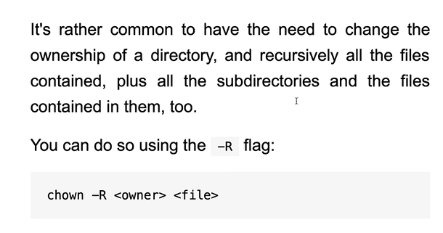

**Even if we want to change the ownership for a directory which we own, the way linux is set up is that we need to use sudo to have the root permissions. We can change the permissions without sudo if we own the file however, if we want to change the ownership then, we have to use sudo no matter what.**

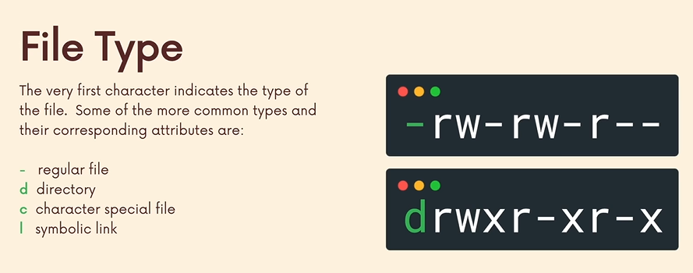

Further we have 3 groups of permissions.

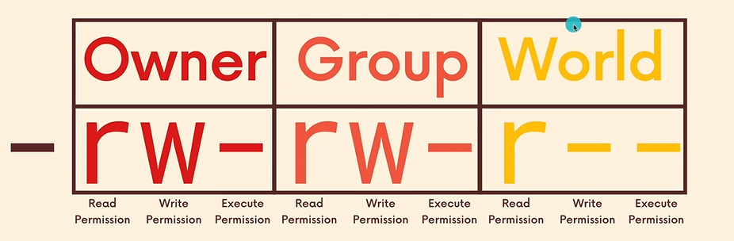

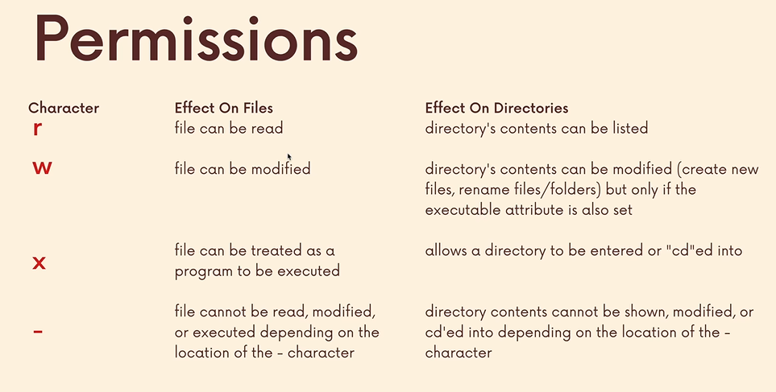

**chmod command (change mode command used to alter permissions)**

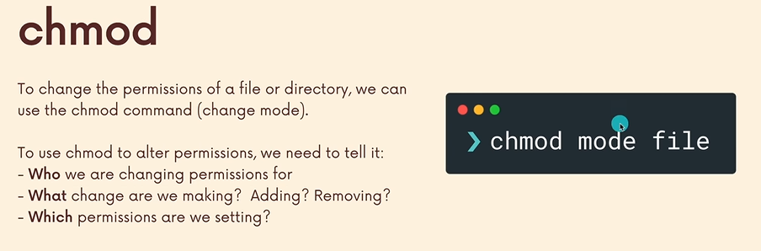

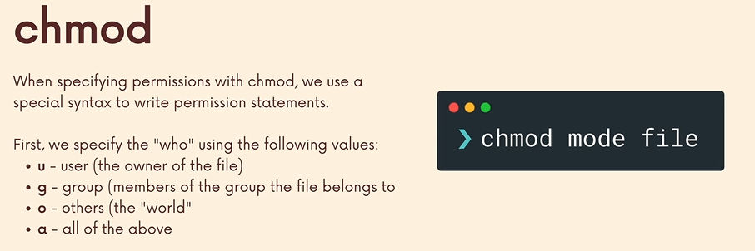

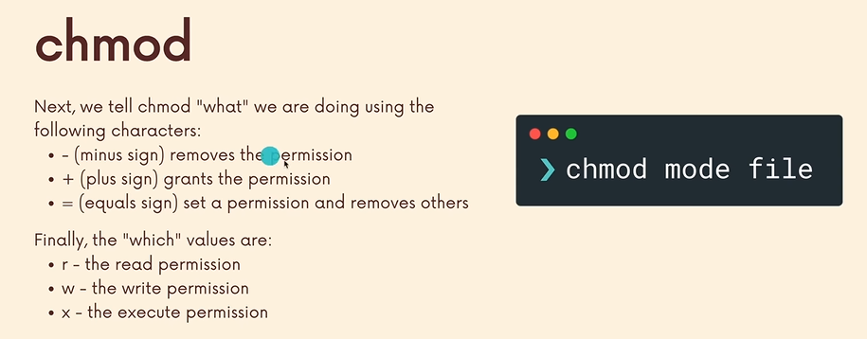

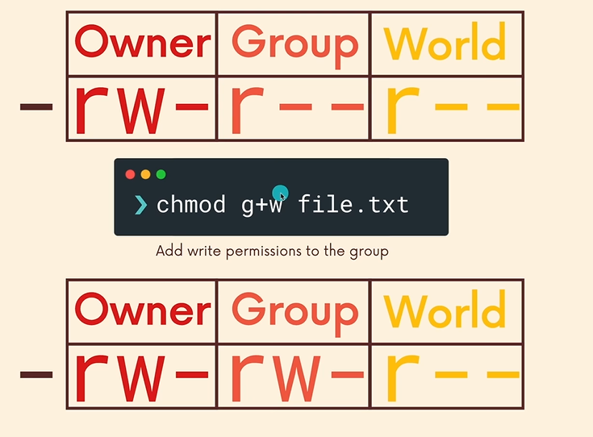

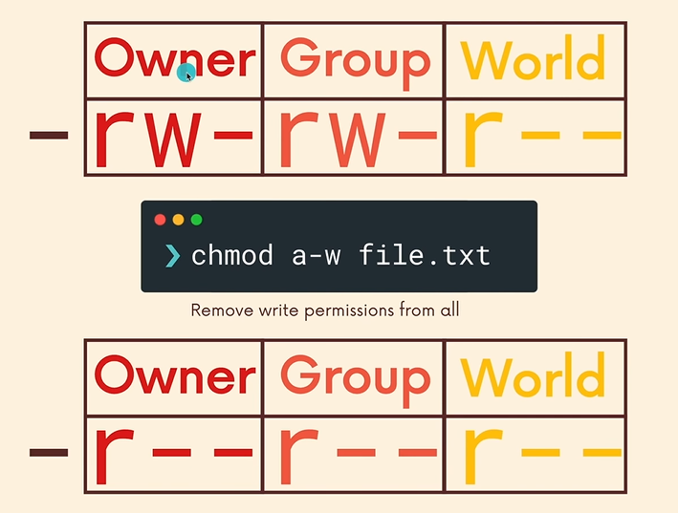

To add all permissions in one go we can type, **chmod a+rwx file.txt**

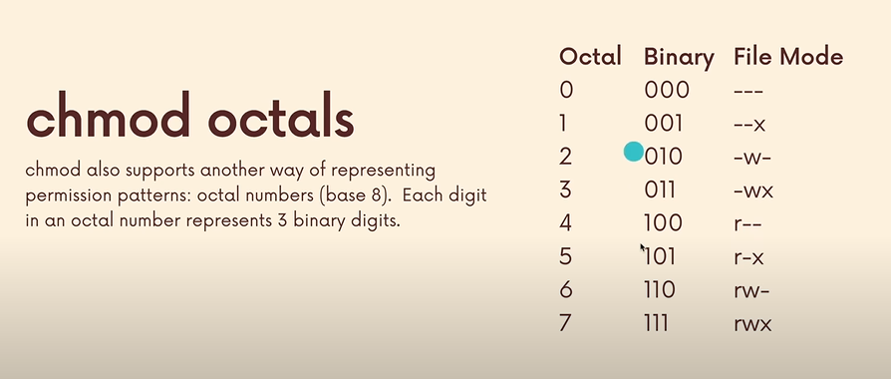

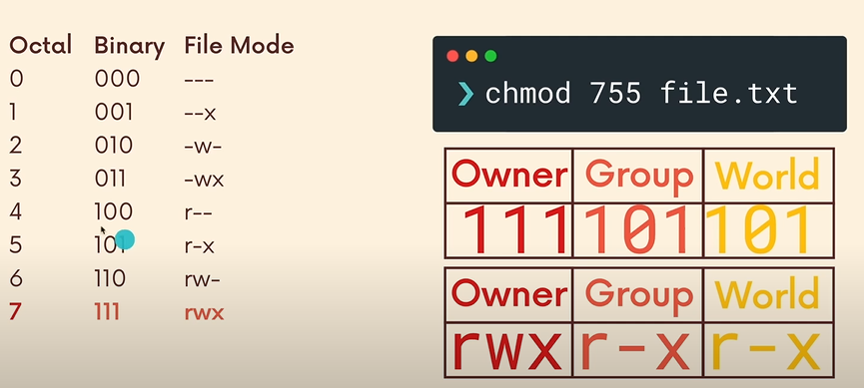

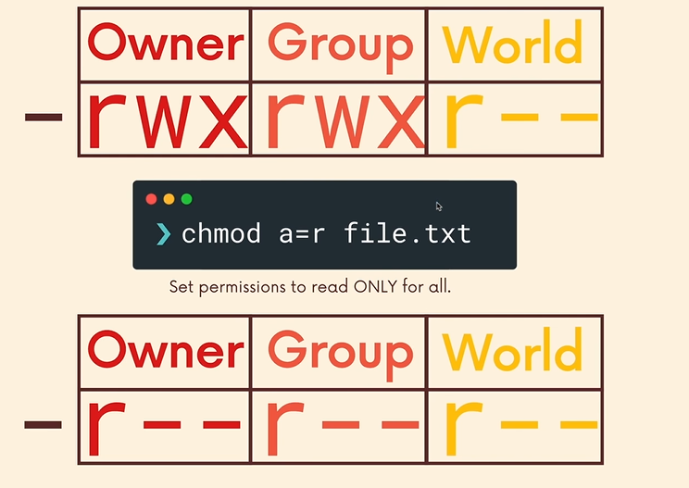

**Sets all to read and removes the other permissions.**